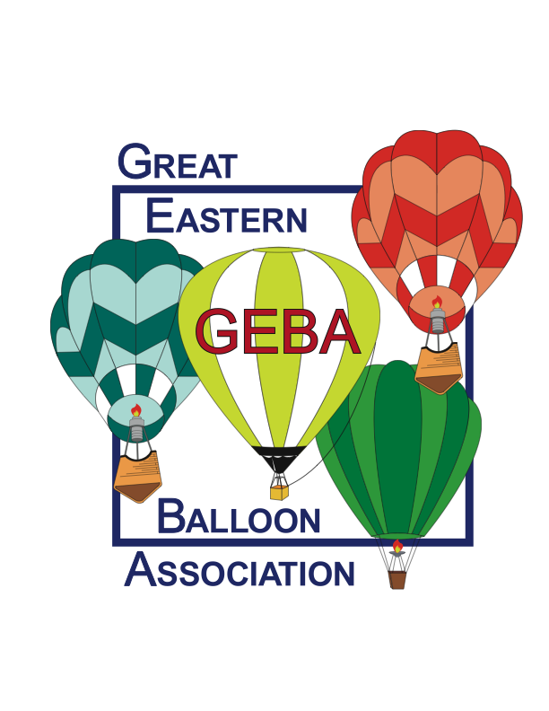
Great Eastern Balloon Association
Continuing Education Seminar Registration
March 6, 2021
ONLINE SEMINAR – Details to follow
Please Read Carefully – Then Neatly Print or Type All Information - Thank You!

Your Name:
Street Address
City: State: Zip:
Home Phone: Cell Phone:
Email address:

Your Status ↓ | Registration Type & Fee ↓ | Circle Only One
GEBA Member  2021 Dues Must Have  Been Paid | - Pilot: (holds commercial/private certificate) **  - Non-Pilot: (crew, observer, student pilot, associate)  - Jr. Balloonist: (GEBA family membership required) | $20 | $
Non-GEBA Member: | - Pilot: ( holds commercial/private certificate) **  - Non-Pilot: (crew, observer, student pilot, associate)  - Jr. Balloonist | $30 | $
Are You A BFA Member: Yes No [circle one] If “Yes” – enter BFA #:
Circle one: commercial pilot private pilot student pilot crew
 |  |  | $
** If you are a pilot, please enter your FAA certificate number:

To register additional people residing at the same address, use the opposite side of this form.

Total $ For Additional Individuals – From Other Side Of This Form | $

TOTAL AMOUNT DUE GEBA: | $

Make check payable to: Great Eastern Balloon Association, Inc.
[Yes, you can write ONE check for BOTH your dues and the safety seminar]

Please mail form & check to: Robin Smith,375 Potomac Drive, Basking Ridge, NJ 07920

Prior to the seminar, you will receive a confirmation package with directions & maps

Do You Need Hotel Information (circle one): Yes - No

This Area For GEBA Use Only:
Date Received | Check Number | Amount

No refunds will be made for cancellations after: February 26, 2021

Use This Side For Additional Individuals At Same Address
Name:
Status | Registration Type & Fee | Circle Only One
GEBA Member  2019 Dues Must Have  Been Paid | - Pilot: ( holds commercial/private certificate)  - Non-Pilot: (crew, observer, student pilot, associate)  - Jr. Balloonist: (GEBA family membership required) | $20 | $
Non-GEBA Member: | - Pilot: ( holds commercial/private certificate)  - Non-Pilot: (crew, observer, student pilot, associate)  - Jr. Balloonist | $30 | $
A BFA Member: Yes No [circle one] If “Yes” – enter BFA #:
Circle one: commercial pilot private pilot student pilot crew
 |  |  | $
If a pilot, enter FAA certificate number:

Name:
Status | Registration Type & Fee | Circle Only One
GEBA Member  2019 Dues Must Have  Been Paid | - Pilot: ( holds commercial/private certificate)  - Non-Pilot: (crew, observer, student pilot, associate)  - Jr. Balloonist: (GEBA family membership required) | $20 | $
Non-GEBA Member: | - Pilot: ( holds commercial/private certificate)  - Non-Pilot: (crew, observer, student pilot, associate)  - Jr. Balloonist | $30 | $
BFA Member: Yes No [circle one] If “Yes” – enter BFA #:
Circle one: commercial pilot private pilot student pilot crew
 |  |  | $
If a pilot, enter FAA certificate number:

Name:
Status | Registration Type & Fee | Circle Only One
GEBA Member  2019 Dues Must Have  Been Paid | - Pilot: ( holds commercial/private certificate)  - Non-Pilot: (crew, observer, student pilot, associate)  - Jr. Balloonist: (GEBA family membership required) | $20 | $
Non-GEBA Member: | - Pilot: ( holds commercial/private certificate)  - Non-Pilot: (crew, observer, student pilot, associate)  - Jr. Balloonist | $30 | $
BFA Member: Yes No [circle one] If “Yes” – enter BFA #:
Circle one: commercial pilot private pilot student pilot crew
 |  |  | $
If a pilot, enter FAA certificate number:

Enter This Total On Other Side Of Form $__________

